Downloading Zoom Recordings and Saving to OneDrive

- Sign in to Zoom
- Click Recordings on the left side navigation.
- Under the cloud recordings tab at the top you there will be a list of your recordings that have been saved to the cloud.
- Click the More button and then Download.
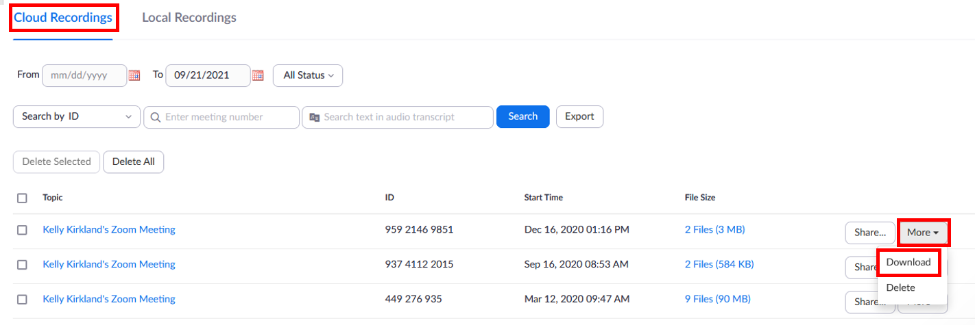
- The file will be saved in your default download location (typically Downloads folder).
- Open your local files (the yellow folder icon on the taskbar).
- Locate the Download folder in the left column and select it so that it opens.
- Find the Zoom recording that was just download and click on it so that it is selected.
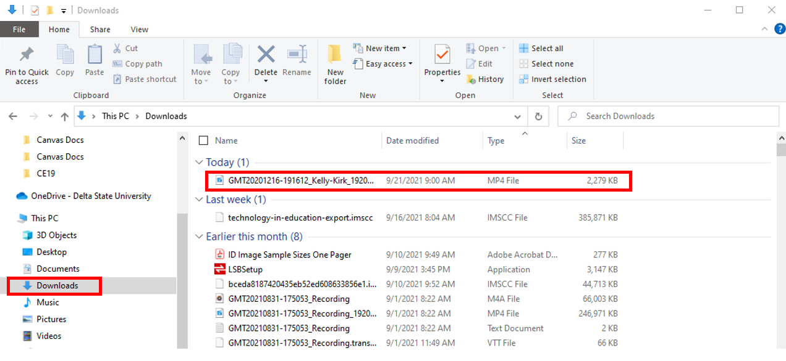
- Next, drag/drop the file into the OneDrive – Delta State University located in the left column.
